**Experiment No. 01**

**Title**: Design a Website Home page using HTML5 tags.

**Batch: B-4 Roll No: 16010422234 Name: Chandana Ramesh Galgali**

**Experiment No: 1**

**Aim:** To plan and design Home page for Website using HTML5 tags.

**Resources needed:** Notepad++, Bracket, Sublime Text, any Web Browser and Internet.

**Theory:**

HyperText Markup Language, commonly referred to as HTML, is the standard markup language used to create web pages. HTML describes the structure of a website semantically along with cues for presentation, making it a markup language, rather than a programming language. HTML is the Web’s core language for creating documents and applications for everyone to use, anywhere.

The language is written in the form of HTML elements consisting of *tags* enclosed in angle brackets (like <html>). Browsers do not display the HTML tags and scripts, but use them to interpret the content of the page. HTML can embed scripts written in languages such as JavaScript which affect the behavior of HTML web pages. HTML can be edited by using professional HTML editors like: Microsoft WebMatrix, Sublime Text etc. However, for learning HTML we recommend a text editor like Notepad (PC) or TextEdit (Mac).

All HTML documents must start with a type declaration: **<!DOCTYPE html>**.

The HTML document itself begins with **<html>** and ends with **</html>**.

The visible part of the HTML document is between **<body>** and **</body>**.

**Sample HTML Document**

<!DOCTYPE html>

<html>

<head>

<title>PageTitle</title>

</head>

<body>

<h1>MyFirstHeading</h1>

<p>Myfirstparagraph.</p>

</body>

</html>

**HTML Tags**

The basic structure of an HTML document includes tags, which surround content and apply meaning to it. HTML tags are **keywords** (tag names) surrounded by **angle brackets**.

**Attributes**

Tags can also have **attributes**, which are extra bits of information. Attributes appear inside the opening tag and their values sit inside quotation marks. They look something like

<tag attribute="value">Margarine</tag>.

**Heading Tags**

Any document starts with a heading. HTML also has six levels of headings, which use the elements **<h1>, <h2>, <h3>, <h4>, <h5>, and <h6>**

*Format:* <h1> A Heading </h1>

**Body Tags** 

The BODY tag surrounds all the content of your site. It allows you to set the look and feel of your site through **its attributes**

.

The TEXT attribute allows you to set the color of the text:

TEXT <BODY TEXT=red>

A page with that body will have red text.

The BGCOLOR attribute allows you to set the color of the background: BGCOLOR <BODY BGCOLOR=blue>

A page with that body will have a blue background.

The BACKGROUND attribute allows you to set an image as the

background:

BACKGROUND <BODY BACKGROUND=monkey.jpg>

A page with that body will have a monkey for a background (if

there was an image monkey.jpg in the same folder as it).

**Paragraph Tag**

The **<p>** tag offers a way to structure your text into different paragraphs. Each paragraph of text should go in between an opening <p> and a closing </p> tag

*Format:* <p> Some text </p>

**Font Tag**

The FONT tags allow you to set the color and size of a specific piece of text. Unlike the BODY tag the FONT tag only changes the text between the opening <FONT> and closing </FONT> tag.

| COLOR | The COLOR attribute allows you to set the color of the text:  <FONT Color=red>Red Text </FONT> |
| --- | --- |
| SIZE | The SIZE attribute allows you to set the size of the text:  <FONT SIZE=6>Big Text </FONT> |

**Line Break Tag**

The BR tag inserts a line break in the page.

*Format*: <br>Some text

**Centering Content**

The CENTER tags align the text between them in the center of the page 

*Format: <*center>Some text</center>

**Horizontal Lines**

Horizontal lines are used to visually break up sections of a document. The **<hr>** tag creates a line from the current position in the document to the right margin and breaks the line accordingly.

*Format:* <hr> Some text

**Links**

The A tag is used for links and anchors. If the link is to another page HREF is set equal to the URL of that page. If the NAME attribute is included instead of the HREF attribute then the A tag is being used to mark a spot in the page that can later be pointed to by a link.

*Format:* <a HREF=”a URL”>the link</a>

<a NAME=ANCHORNAME></a>

**Images**

This tag is used to insert an image into a page. The image is displayed where the <IMG> tag is inserted. The SRC tag tells the browser what image to insert. The width tag tells the browser what the dimensions of the image should be. If the dimensions of the image are different than what is given the browser stretches the image to make it fit. The height tag tells the browser what the dimensions of the image should be. If the dimensions of the image are different than what is given the browser stretches the image to make it fit.

*Format:* <img src="photo.jpg">

**Tables**

The <table> tag must surround an entire table. Its attributes determine how the table looks.

| BORDER | This defines how big the borders of a table will be. |
| --- | --- |
| CELLPADDING | This defines how far from the edge of a cell the content in that cell will be |
| CELLSPACING | This defines how far apart the cells of the table will be. |
| WIDTH | This defines the width of the table |
| BGCOLOR | This defines the background color of the table. If a color is specified in the TR or TD tags BGCOLOR is ignored for that row, or cell respectively. |

**List**

The LI tag creates a new element in an ordered or unordered list. The OL tags start and end an ordered list. All of the elements in the list must be inside these two tags.

Format:

<OL>

<LI>element one.

<LI>element two.

</OL>

HTML is mark-up language – provides a way to describe structure of text and graphics on a web page using its set of elements and attributes, and deals with alignment of elements on the web page too, derived from SGML. HTML 5.0 was started by the World Wide Consortium (W3C) and the Web Hypertext Application Technology Working Group (WHATWG). HTML 5.0 reduces the need for external plug-ins. 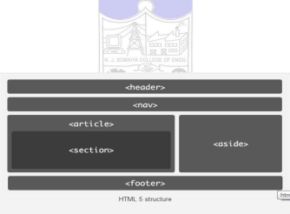

Fig 1. HTML 5 structure

**New features in HTML5.0**

∙ New content specific Structural elements like article, footer, header, nav, section…etc

∙ New Form elements and attributes like calendar, date, time, email, url, search, Canvas Element to draw graphic on a web page using JavaScript

∙ Video and Audio elements for media playback

∙ Geo Location

**Video Tag**

Video element is used for playing videos or movies. HTML 5 video element is a standard way to include video. You can play the video without the help of external plugins like flash player.

**Syntax:**

<video src="myvideo.mp4" controls=“controls”>

Your Browser won’t support this tag

</video>



**Video Attributes:**

| **Attributes** | **Value** | **Description** |
| --- | --- | --- |
| src | url | Specify the location of the video file |
| height | pixels | pixels Sets the height of the video player |
| width | pixels | pixels Sets the width of the video player |

**Audio Tag**

Audio element is used for playing audio files.Audio element represents an audio or sound stream HTML 5 audio element is a standard way to include audio. You can play the audio without the help of external plug-ins like flash players. Content can be given between the opening and closing of the audio tag. This content should not be shown by the user agents and is intended for the older browsers which do not support audio tag.

**Syntax:**

<audio src=“myvideo.mp3” controls=“controls”>

Your Browser won’t support this tag

</audio>

1. src attribute is used to identify the media

2. controls attribute is used to specify whether or not to display audio controls.

**Audio attributes:** 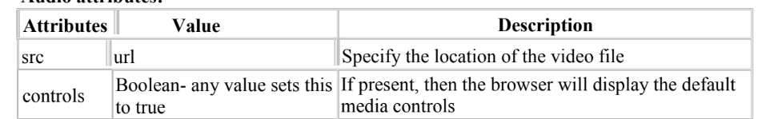

**The different types of input types for selecting date and time are:**

| **Input Types** | **Description** |
| --- | --- |
| date | Selects date, month and year |
| month | Selects month and year |
| week | Selects week and year |
| Time | Selects time (hour and minute) |
| datetime | Selects time, date, month and year(UTC time) |

∙ **Search:**

Search input is used for search fields like Yahoo search, Google search or Site search.

**Syntax:**

<input type="search" >

∙ **Color:**

Color input type is used for input fields that should contain a color. If you use color type , it will allow you to pick a color from the color picker.

**Syntax:**

<input type="color" >

**Activities:**

To design a web page illustrating the following tags heading, content, background color, table, list and image, HTML structural elements tags, audio and video tags. To set the values of minimum two attributes for the above mentioned tags.

**Results: (Document printout as per the format discussed by the faculty *t*)**

Display of the designed webpage along with the code.

Code:

First File:

<!DOCTYPE html>

<html lang="en">

<head>

<link rel="stylesheet" href="https://fonts.googleapis.com/css?family=Sofia">

<title>Perfume Emporium</title>

<style>

body {

background-color: #deb3ad;

font-family: "Sofia", sans-serif;

margin: 20px;

}

h1 {

font-family: "Sofia", sans-serif;

color: #69737A;

}

ul {

list-style-type: circle;

font-family: "Sofia", sans-serif;

color: #663635;

}

img {

margin-right: 50px;

border: 1px solid #000000;

}

</style>

</head>

<body link="#663635" vlink="#663635">

<header>

<h1><center>Perfume Emporium<font color="c58e02" size="3"><sub> the potion of elegance <3</sub></font></center></h1>

</header>

<nav>

<ul>

<li><a href="#samepage">Home</a></li>

<li><a href="C:\Users\chand\Downloads\IV SEM\WP-1\exp1b.html">Shop</a></li>

<li><a href="C:\Users\chand\Downloads\IV SEM\WP-1\exp1c.html">About Us</a></li>

<li><a href="mailto:chandana.galgali@gmail.com">Contact</a></li>

</ul>

</nav>

<img src="C:\Users\chand\OneDrive\Pictures\Saved Pictures\perfume.jpg" height="321" width="250"></img>

<img src="C:\Users\chand\OneDrive\Pictures\Saved Pictures\fragrances.jpg" height="321" width="250"></img>

<img src="C:\Users\chand\OneDrive\Pictures\Saved Pictures\scent.jpg" height="321" width="250"></img>

<img src="C:\Users\chand\OneDrive\Pictures\Saved Pictures\mist.jpg" height="321" width="250"></img>

<h2>Popular Perfume Categories</h2>

<ul>

<li>Fruity Scents</li>

<p><font color="EFEFEF">Immerse yourself in a burst of vibrant energy with our collection of Fruity Scents.Experience the refreshing and sweet notes of succulent fruits like citrus, berries, and tropical delights. Perfect for those who seek a lively and uplifting fragrance that captures the essence of nature's juiciest offerings.</font></p>

<p><a href="C:\Users\chand\Downloads\IV SEM\WP-1\exp1b.html #fruity">Click to know more -></a> </p>

<li>Floral Fragrances</li>

<p><font color="EFEFEF">Indulge your senses in the timeless elegance of Floral Fragrances. Each bottle encapsulates the delicate beauty of blooming flowers, from romantic roses to enchanting lilies. Let the graceful and captivating floral notes transport you to a garden in full bloom, leaving a trail of charm wherever you go.</font></p>

<p><a href="C:\Users\chand\Downloads\IV SEM\WP-1\exp1b.html #floral">Click to know more -></a> </p>

<li>Woody Notes</li>

<p><font color="EFEFEF">Discover the allure of sophistication with our Woody Notes collection. Grounded and refined, these fragrances blend earthy tones of sandalwood, cedar, and vetiver to create a warm and comforting embrace. Perfect for those who appreciate the timeless and distinct aroma of the great outdoors, captured in a bottle.</font></p>

<p><a href="C:\Users\chand\Downloads\IV SEM\WP-1\exp1b.html #woody">Click to know more -></a> </p>

<li>Spicy Aromas</li>

<p><font color="EFEFEF">Ignite your senses with our Spicy Aromas collection. Bold, daring, and full of character, these fragrances combine a medley of spices such as cinnamon, pepper, and cloves. Unleash the passionate and fiery side of your personality with scents that add a touch of mystery and excitement to your everyday moments.</font></p>

<p><a href="C:\Users\chand\Downloads\IV SEM\WP-1\exp1b.html #spicy">Click to know more -></a> </p>

</ul>

<hr>

<center><p><font color="c58e02">Our Latest Launch ~ The Egoiste Collection ~ From Chanel</font></p></center>

<center>

<video height="500" width="1000" controls>

<source src="C:\Users\chand\Downloads\Perfume_commercial.mp4" type="video/mp4">

</video>

</center>

<hr>

<footer>

<p><font color="#663635">&copy; Perfume Emporium (since 2004)</p>

</footer>

</body>

</html>

Second File:

<html>

<title>

Shop

</title>

<style>

body {

background-color: #deb3ad;

font-family: "Sofia", sans-serif;

margin: 20px;

}

h2 {

font-family: "Sofia", sans-serif;

color: #69737A;

}

table {

background-color: #69737A;

border-collapse: collapse;

width: 50%;

margin-top: 20px;

}

th {

color: #deb3ad;

font-family: "Sofia", sans-serif;

border: 1px solid #000000;

padding: 8px;

text-align: center;

}

td {

color: #EFEFEF;

font-family: "Sofia", sans-serif;

border: 1px solid #000000;

padding: 8px;

text-align: center;

}

img {

border: 1px solid #000000;

margin-right: 50px;

}

</style>

<body>

<link rel="stylesheet" href="https://fonts.googleapis.com/css?family=Sofia">

<h2><marquee direction="right">~ Featured Perfumes ~</marquee></h2>

<center>

<table>

<tr>

<th>Perfume Name</th>

<th>Brand</th>

<th>Price</th>

</tr>

<tr>

<td>N 5 Pearls</td>

<td>Chanel</td>

<td>$109.00</td>

</tr>

<tr>

<td>Lady Cheryl</td>

<td>Miss Dior</td>

<td>$92.00</td>

</tr>

<tr>

<td>She is mine</td>

<td>YSL</td>

<td>$87.00</td>

</tr>

<tr>

<td>Just Bloom</td>

<td>Collezione Privata</td>

<td>$79.00</td>

</tr>

</table>

</center>

<br><br>

<img src="C:\Users\chand\OneDrive\Pictures\Saved Pictures\c1.jpeg" height="321" width="250"></img>

<img src="C:\Users\chand\OneDrive\Pictures\Saved Pictures\c2.jpg" height="321" width="250"></img>

<img src="C:\Users\chand\OneDrive\Pictures\Saved Pictures\21.jpeg" height="321" width="250"></img>

<img src="C:\Users\chand\OneDrive\Pictures\Saved Pictures\22.jpeg" height="321" width="250"></img>

<ul>

<li><a name="fruity">Fruity Scents</a></li>

<table>

<tr>

<th>Perfume</th>

<th>Visuals</th>

<th>Notes</th>

<th>Price</th>

</tr>

<tr>

<td>Dolce & Gabbana Light Blue</td>

<td><img src="C:\Users\chand\OneDrive\Pictures\Saved Pictures\fruity1.jpg" height="250" width="180"></img></td>

<td>Sicilian Lemon, Apple, Cedarwood</td>

<td>$70 - $100</td>

</tr>

<tr>

<td>Marc Jacobs Daisy Eau So Fresh</td>

<td><img src="C:\Users\chand\OneDrive\Pictures\Saved Pictures\fruity2.jpeg" height="250" width="180"></img></td>

<td>Raspberry, Grapefruit, Pear</td>

<td>$80 - $120</td>

</tr>

<tr>

<td>Chanel Chance Eau Tendre</td>

<td><img src="C:\Users\chand\OneDrive\Pictures\Saved Pictures\fruity3.jpeg" height="250" width="180"></img></td>

<td>Grapefruit, Quince, Jasmine</td>

<td>$80 - $130</td>

</tr>

<tr>

<td>Versace Bright Crystal</td>

<td><img src="C:\Users\chand\OneDrive\Pictures\Saved Pictures\fruity4.png" height="250" width="180"></img></td>

<td> Pomegranate, Yuzu, Peony</td>

<td>$60 - $100</td>

</tr>

</table>

<br>

<li><a name="floral">Floral Fragrances</a></li>

<table>

<tr>

<th>Perfume</th>

<th>Visuals</th>

<th>Notes</th>

<th>Price</th>

</tr>

<tr>

<td>Chloe Nomade</td>

<td><img src="C:\Users\chand\OneDrive\Pictures\Saved Pictures\floral1.jpeg" height="250" width="180"></img></td>

<td>Freesia, Mirabelle, Oakmoss</td>

<td>$80 - $120</td>

</tr>

<tr>

<td>Gucci Bloom</td>

<td><img src="C:\Users\chand\OneDrive\Pictures\Saved Pictures\floral2.jpeg" height="250" width="180"></img></td>

<td>Tuberose, Jasmine, Rangoon Creeper</td>

<td>$90 - $150</td>

</tr>

<tr>

<td>Yves Saint Laurent Mon Paris</td>

<td><img src="C:\Users\chand\OneDrive\Pictures\Saved Pictures\floral3.jpeg" height="250" width="180"></img></td>

<td>Strawberry, Raspberry, Peony</td>

<td>$90 - $140</td>

</tr>

<tr>

<td>Dior J'adore</td>

<td><img src="C:\Users\chand\OneDrive\Pictures\Saved Pictures\floral4.jpeg" height="250" width="180"></img></td>

<td>Rose, Jasmine, Ylang-Ylang</td>

<td>$100 - $150</td>

</tr>

</table>

<br>

<li><a name="woody">Woody Notes</a></li>

<table>

<tr>

<th>Perfume</th>

<th>Visuals</th>

<th>Notes</th>

<th>Price</th>

</tr>

<tr>

<td>Tom Ford Black Orchid</td>

<td><img src="C:\Users\chand\OneDrive\Pictures\Saved Pictures\woody1.jpeg" height="250" width="180"></img></td>

<td>Black Truffle, Patchouli, Vanilla</td>

<td>$120 - $180</td>

</tr>

<tr>

<td>Byredo Gypsy Water</td>

<td><img src="C:\Users\chand\OneDrive\Pictures\Saved Pictures\woody2.jpeg" height="250" width="180"></img></td>

<td>Juniper Berries, Incense, Amber</td>

<td>$150 - $230</td>

</tr>

<tr>

<td>Jo Malone English Oak & Hazelnut</td>

<td><img src="C:\Users\chand\OneDrive\Pictures\Saved Pictures\woody3.jpeg" height="250" width="180"></img></td>

<td>Green Hazelnut, Cedarwood, Roasted Oak</td>

<td>$70 - $110</td>

</tr>

<tr>

<td>Bvlgari Man in Black</td>

<td><img src="C:\Users\chand\OneDrive\Pictures\Saved Pictures\woody4.jpeg" height="250" width="180"></img></td>

<td>Rum, Leather, Tonka Bean</td>

<td>$80 - $120</td>

</tr>

</table>

<br>

<li><a name="spicy">Spicy Aromas</a></li>

<table>

<tr>

<th>Perfume</th>

<th>Visuals</th>

<th>Notes</th>

<th>Price</th>

</tr>

<tr>

<td>Yves Saint Laurent Black Opium</td>

<td><img src="C:\Users\chand\OneDrive\Pictures\Saved Pictures\spicy1.jpeg" height="250" width="180"></img></td>

<td>Coffee, Vanilla, White Flowers</td>

<td>$90 - $140</td>

</tr>

<tr>

<td>Viktor & Rolf Spicebomb</td>

<td><img src="C:\Users\chand\OneDrive\Pictures\Saved Pictures\spicy2.jpeg" height="250" width="180"></img></td>

<td>Bergamot, Cinnamon, Leather</td>

<td>$92.00</td>

</tr>

<tr>

<td>Armani Code Profumo</td>

<td><img src="C:\Users\chand\OneDrive\Pictures\Saved Pictures\spicy3.jpeg" height="250" width="180"></img></td>

<td>Cardamom, Leather, Tonka Bean</td>

<td>$80 - $130</td>

</tr>

<tr>

<td>Dolce & Gabbana The One for Men</td>

<td><img src="C:\Users\chand\OneDrive\Pictures\Saved Pictures\spicy4.jpeg" height="250" width="180"></img></td>

<td>Coriander, Ginger, Tobacco</td>

<td>$70 - $110</td>

</tr>

</table>

</ul>

</body>

<hr>

<footer>

<a href="C:\Users\chand\Downloads\IV SEM\WP-1\exp1.html"><- Back to Home</a>

<p>&copy; Perfume Emporium (since 2004)</p>

</footer>

</html>

Third File:

<html>

<title>

About Perfume Emporium

</title>

<style>

body {

background-color: #deb3ad;

font-family: "Sofia", sans-serif;

margin: 20px;

}

h3 {

font-family: "Sofia", sans-serif;

color: #69737A;

}

img {

border: 1px solid #000000;

margin-right: 50px;

}

</style>

<body>

<link rel="stylesheet" href="https://fonts.googleapis.com/css?family=Sofia">

<h3><center>Welcome to our website!</center></h3>

<p><font size="4" color="EFEFEF">Welcome to Perfume Emporium, where enchanting fragrances meet timeless elegance! Our passion for scents goes beyond the ordinary, and we invite you to indulge in the world of captivating aromas that we've curated just for you.

<br>

At Perfume Emporium, we believe that a fragrance is more than just a scent; it's a personal expression of style, a journey into memories, and an invisible accessory that leaves a lasting impression. Our collection features a symphony of exquisite perfumes, each bottle telling a unique story and capturing the essence of sophistication.

<br>

Dive into a realm of olfactory delights as you explore our carefully selected range of fragrances from renowned international brands and hidden gems waiting to be discovered. From the classic to the avant-garde, we have something for every taste and occasion.

<br>

What sets Perfume Emporium apart is our commitment to quality and authenticity. Every fragrance in our inventory is sourced directly from the most reputable perfumeries, ensuring that you receive only the finest scents. We understand that choosing a perfume is a personal experience, and our knowledgeable staff is here to guide you, providing personalized recommendations tailored to your preferences.

<br>

Immerse yourself in the luxury of Perfume Emporium, where the art of fragrance meets a world of possibilities. Whether you're searching for a signature scent or a unique gift, we invite you to explore our online boutique and discover the magic of Perfume Emporium – where every spray is a celebration of individuality and style.

<br>

Indulge your senses, create lasting memories, and elevate your everyday moments with Perfume Emporium – because life is too beautiful not to smell amazing!</font></p>

<center><img src="C:\Users\chand\OneDrive\Pictures\Saved Pictures\bg.jpg"></img></center>

</body>

<hr>

<footer>

<a href="C:\Users\chand\Downloads\IV SEM\WP-1\exp1.html"><- Back to Home</a>

<p>&copy; Perfume Emporium (since 2004)</p>

</footer>

</html>

Website:

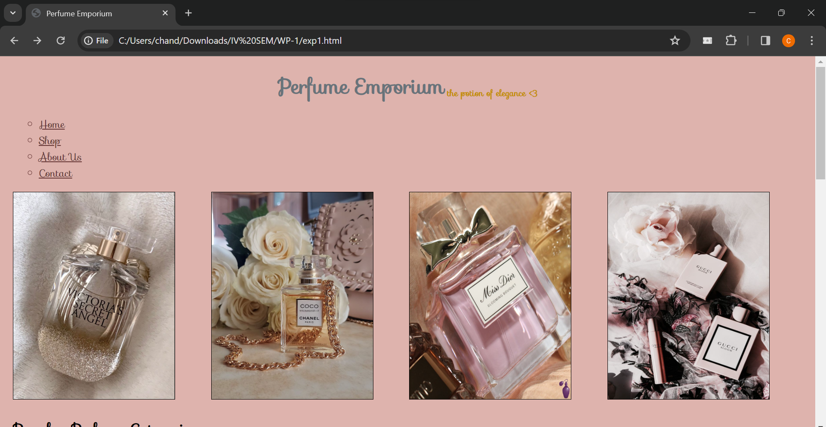

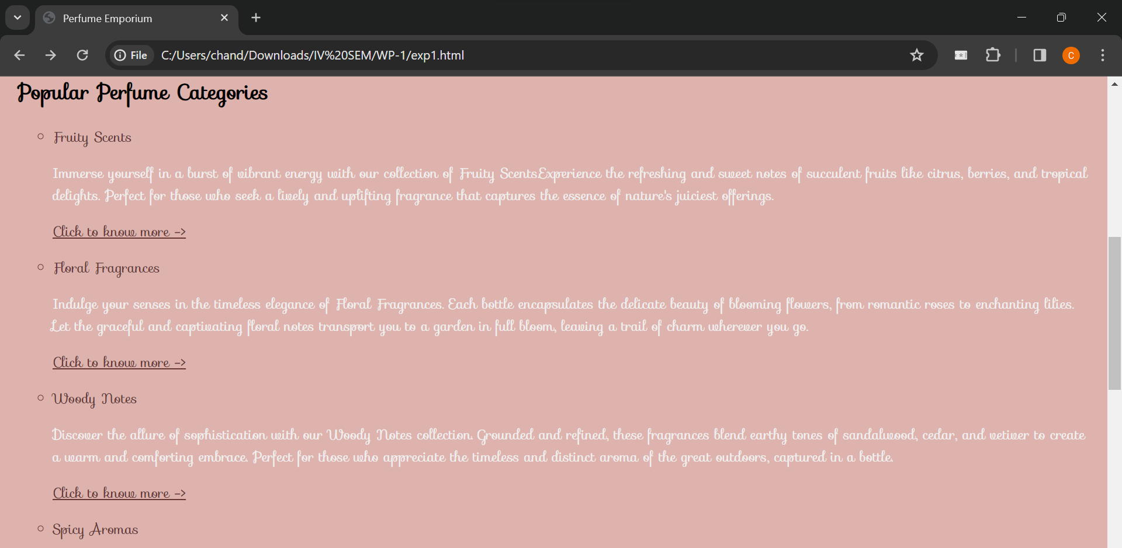

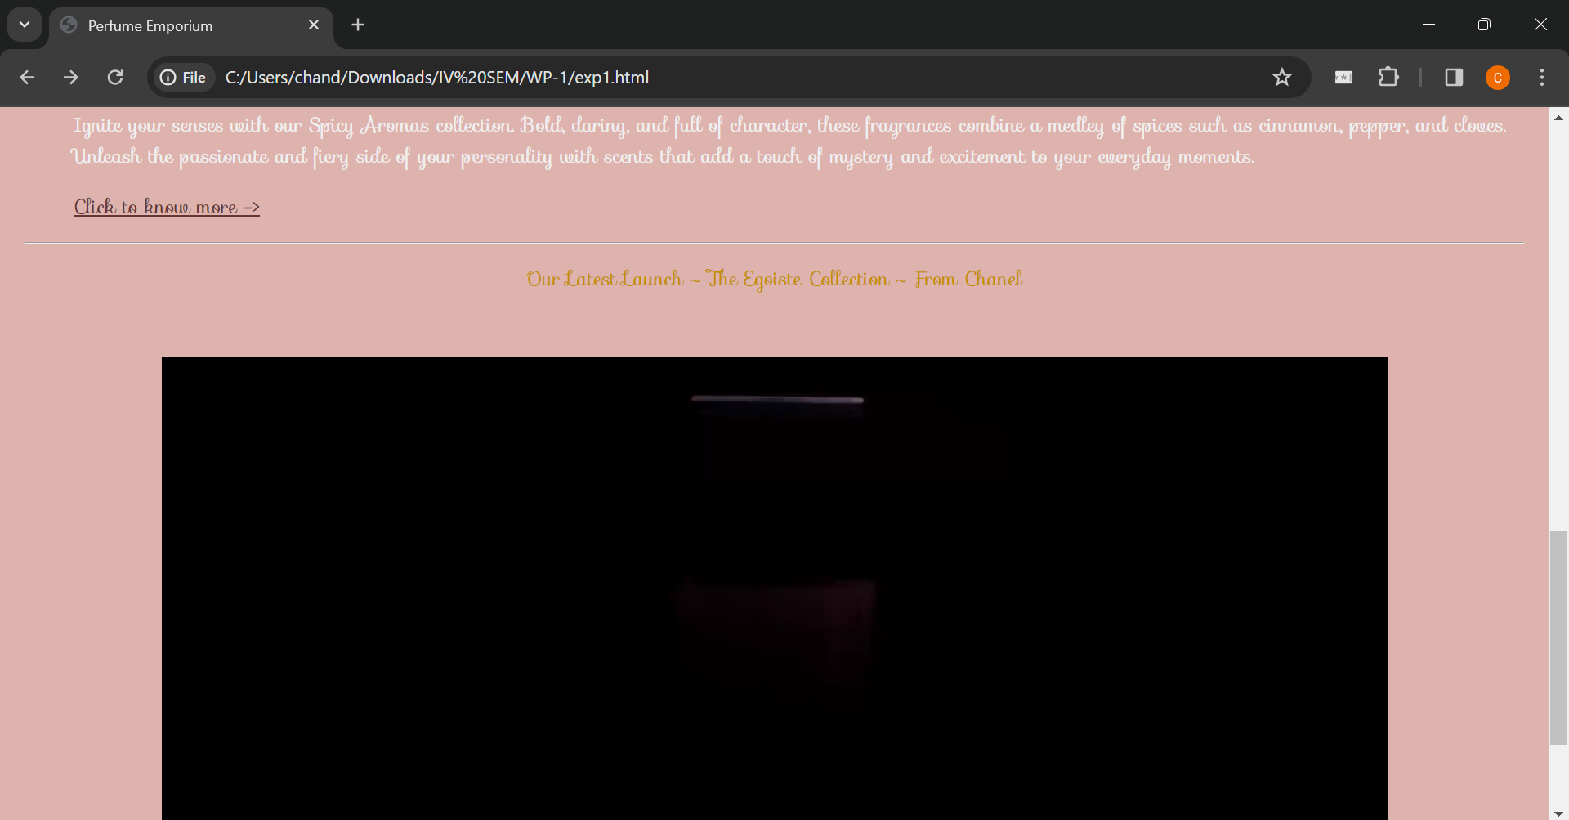

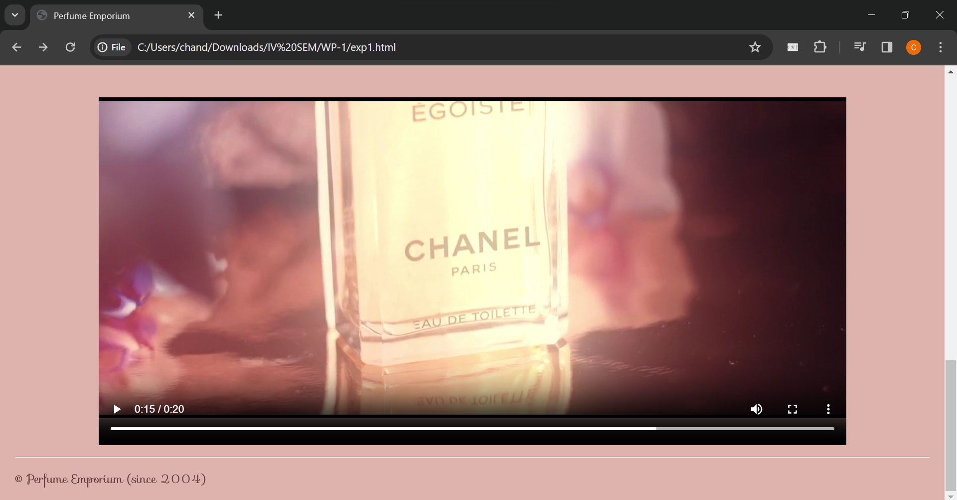

Clicking on ‘Shop’ (present in the header section of file1),

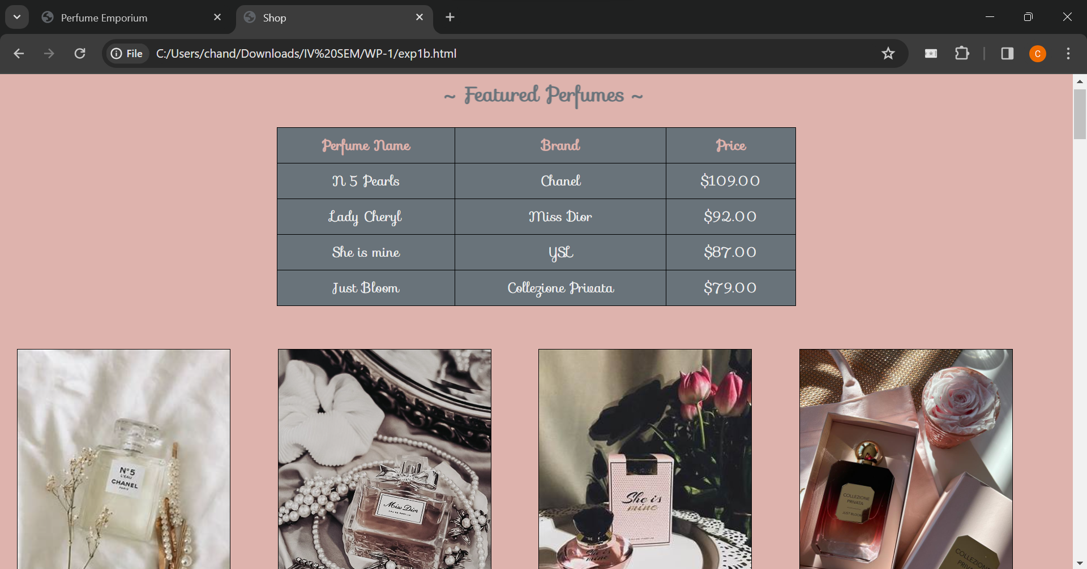

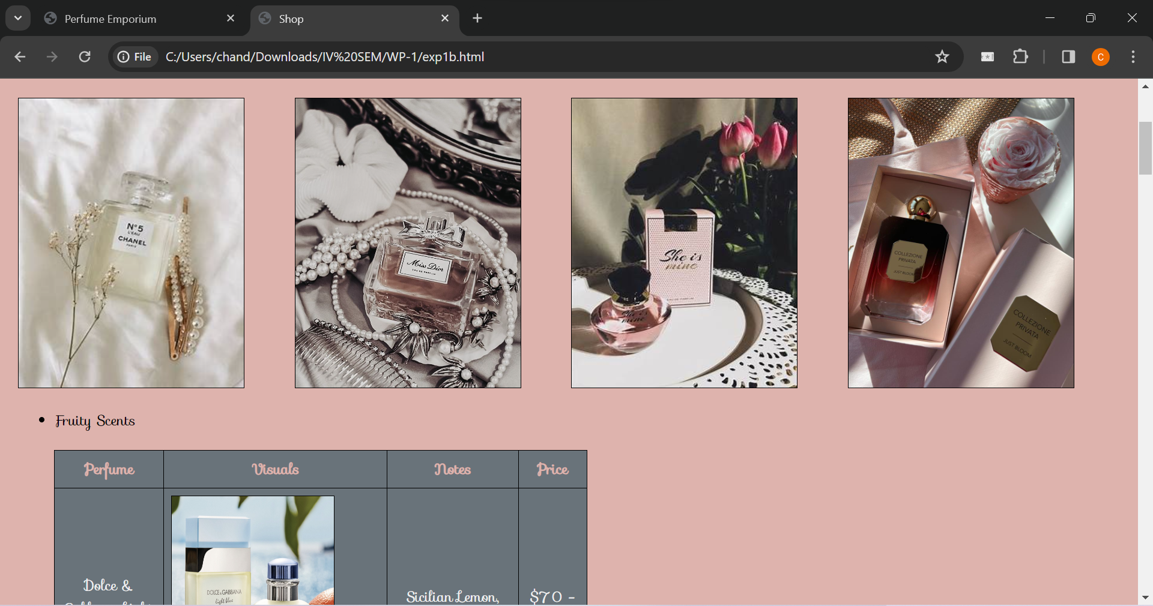

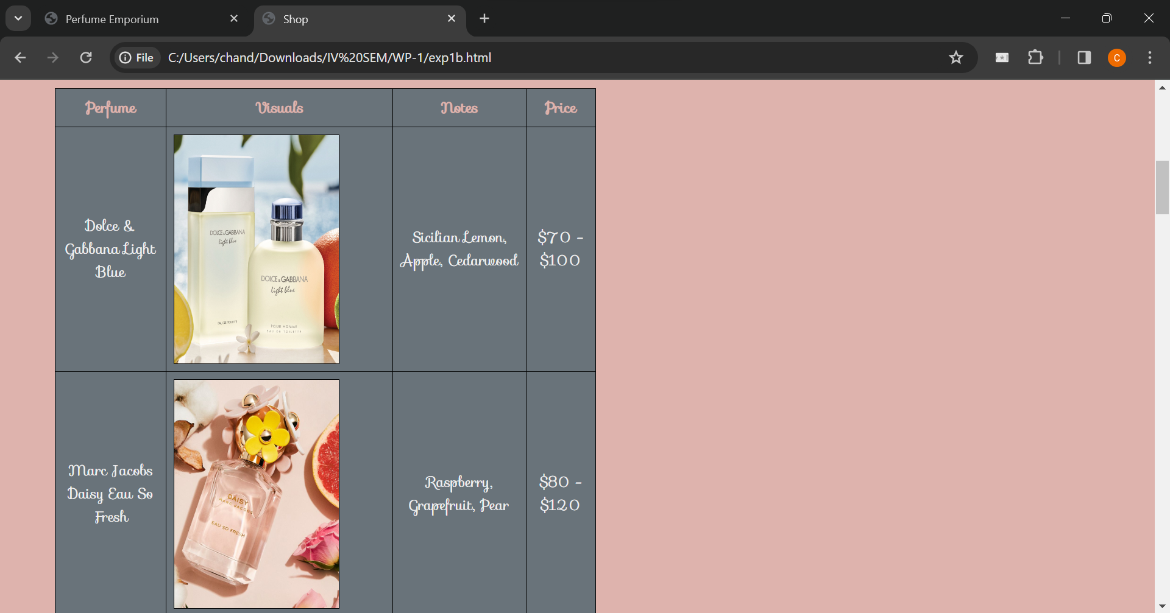

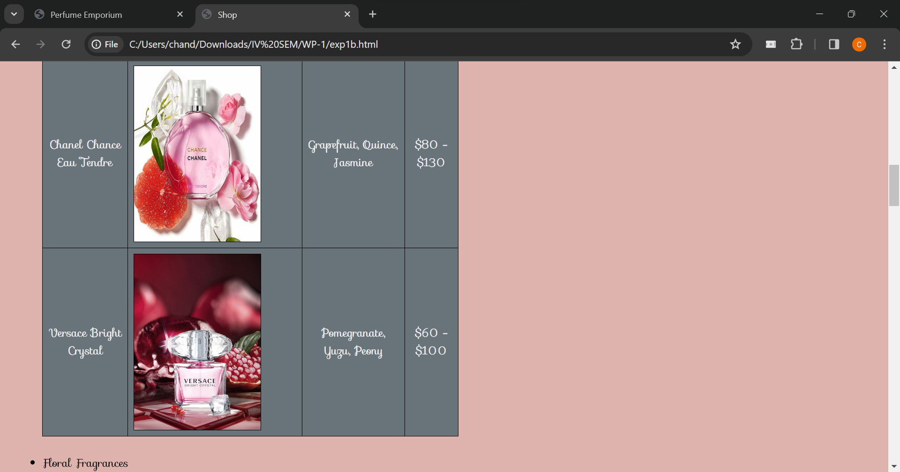

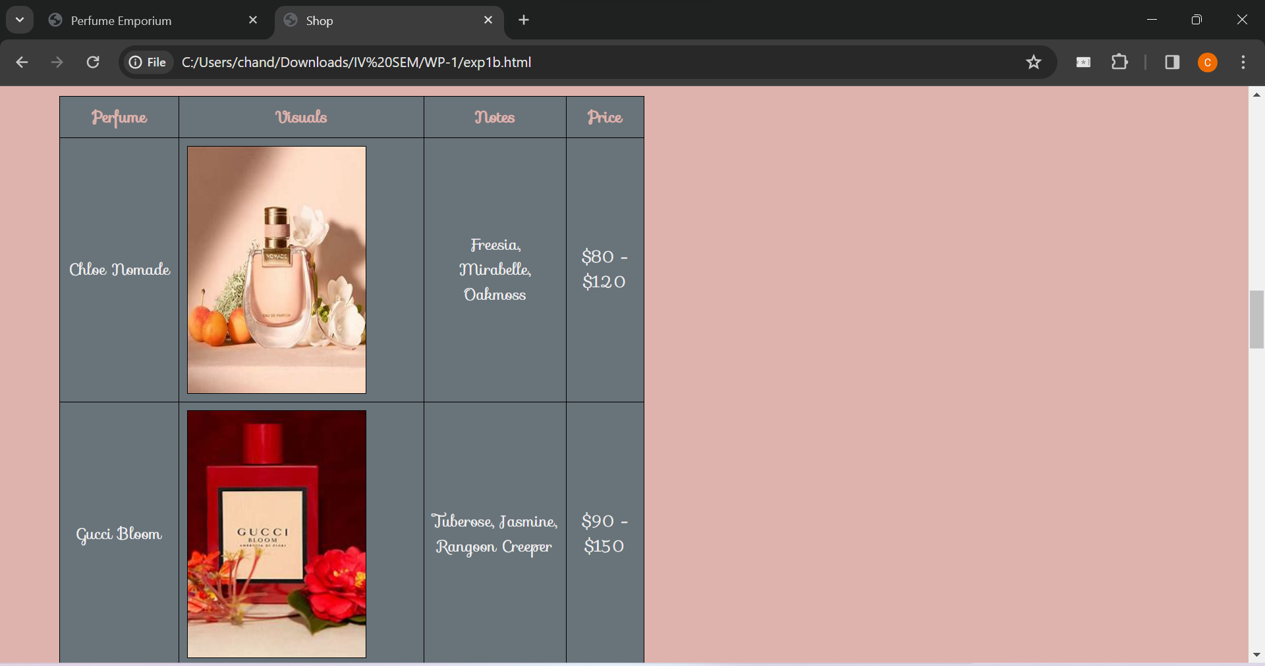

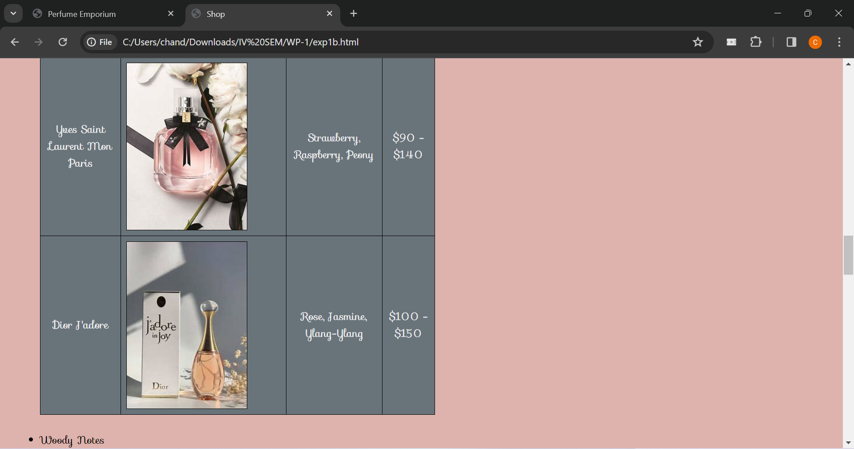

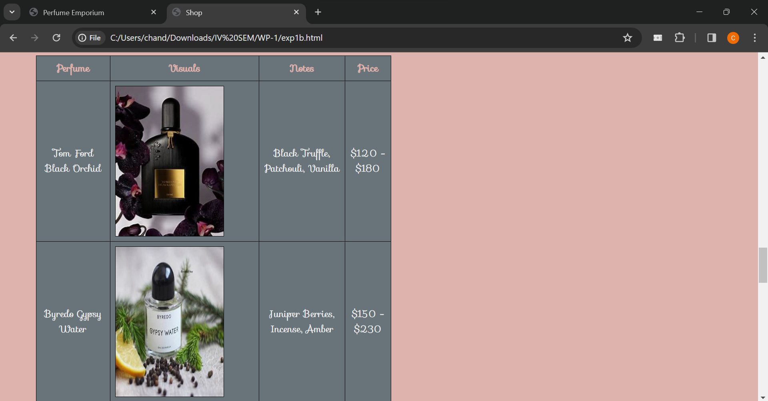

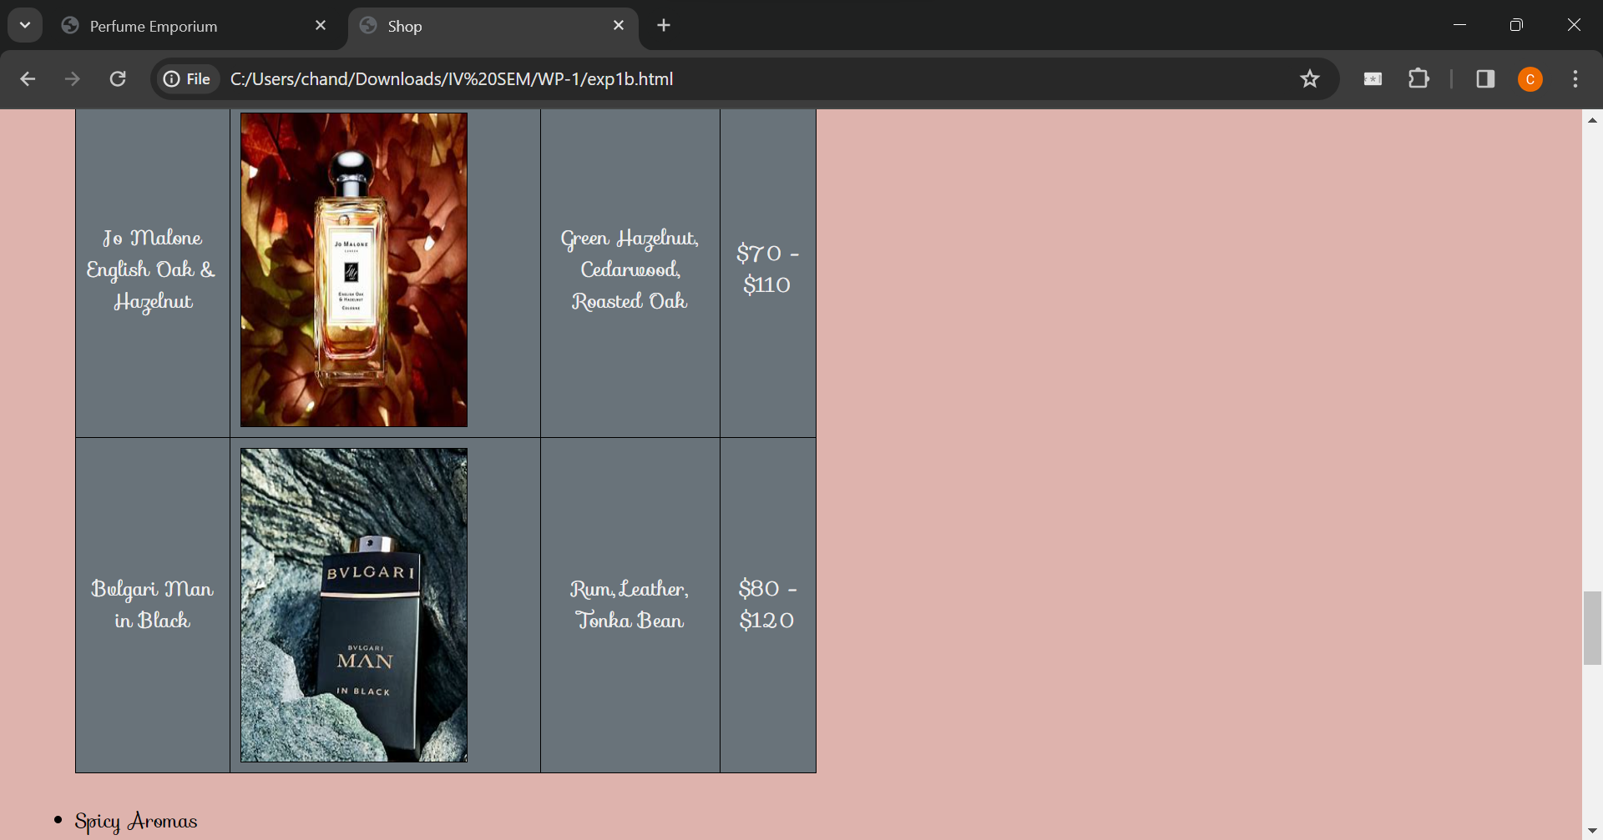

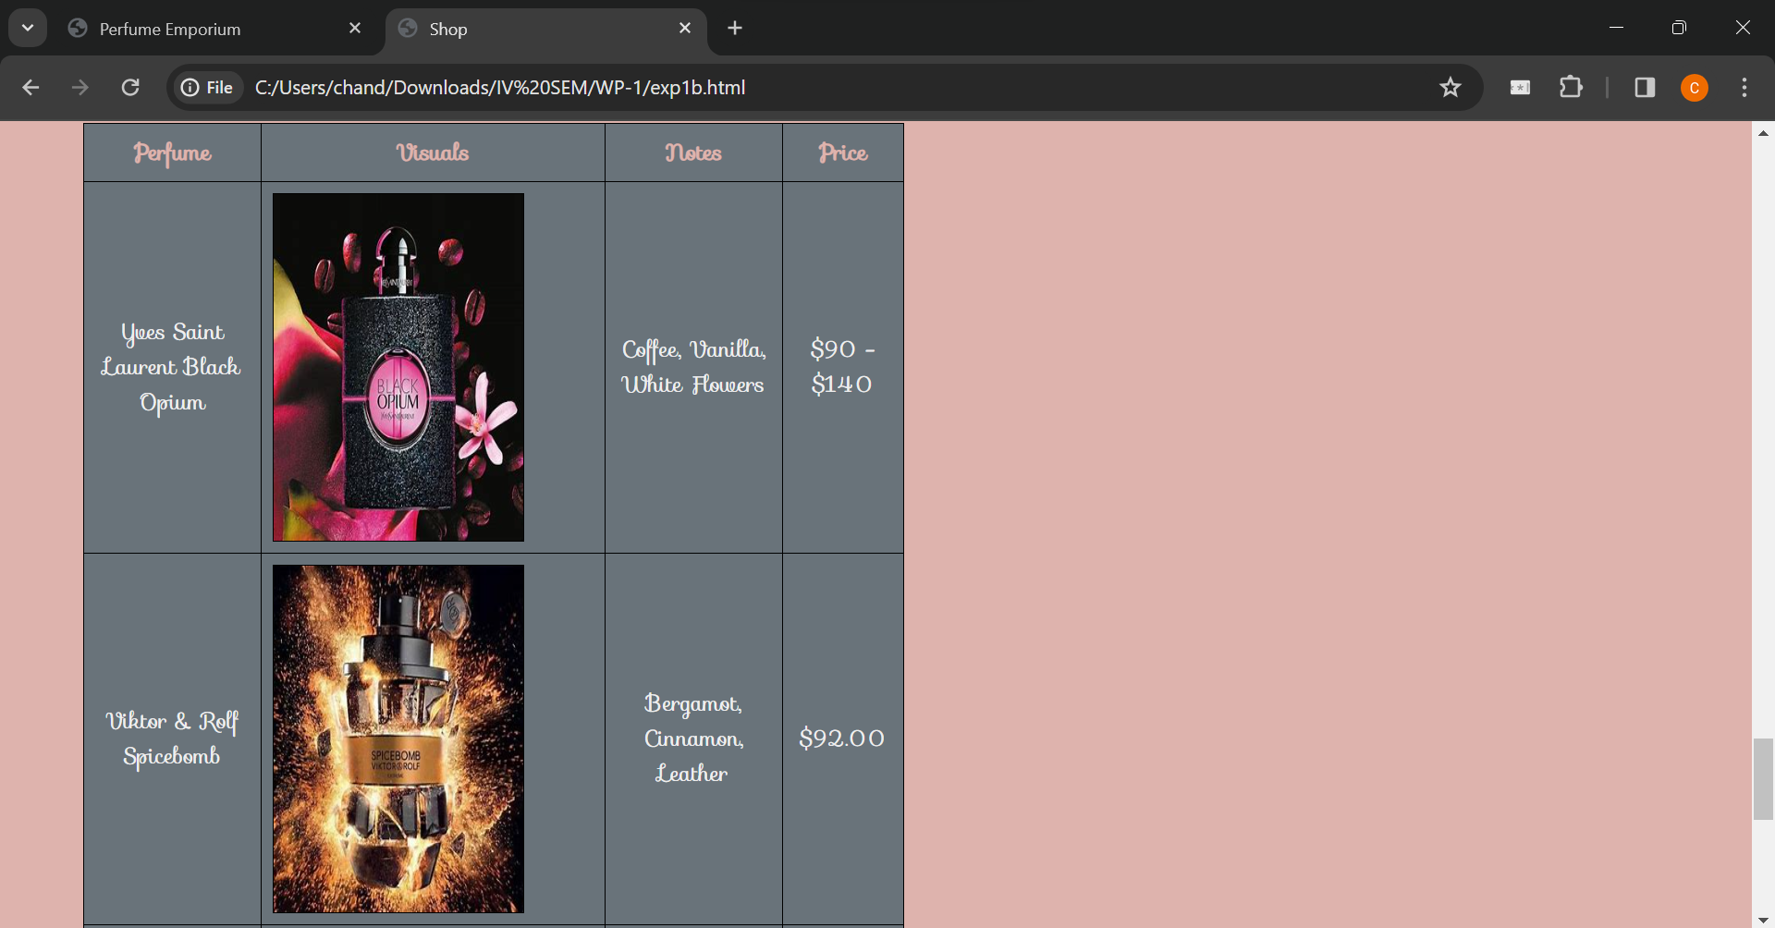

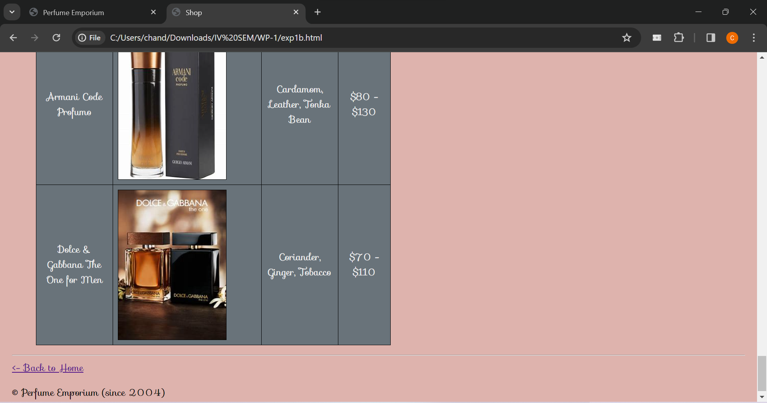

Clicking on ‘Back to Home’ in file 2, then on ‘About Us’ (present in the header section of file1)

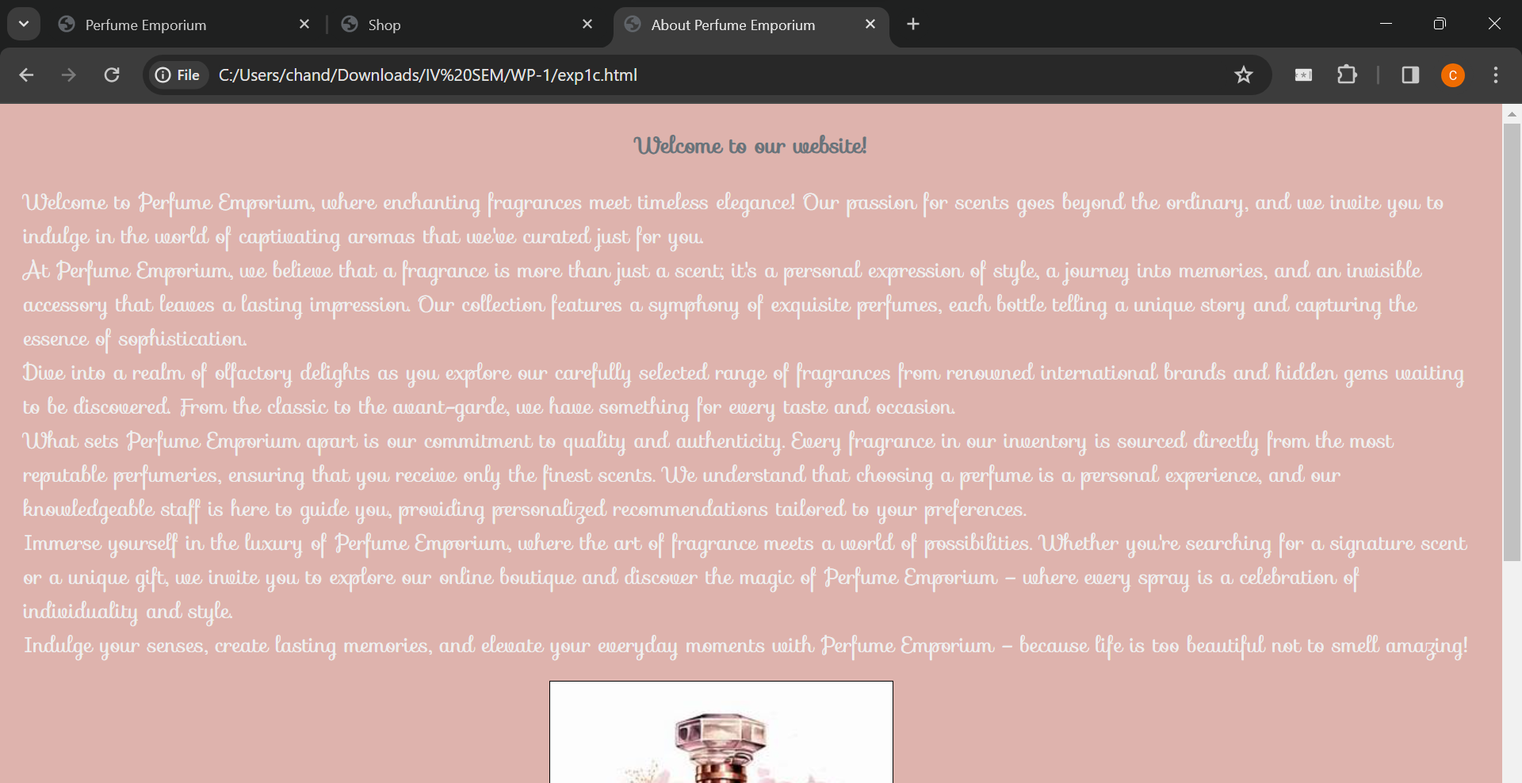

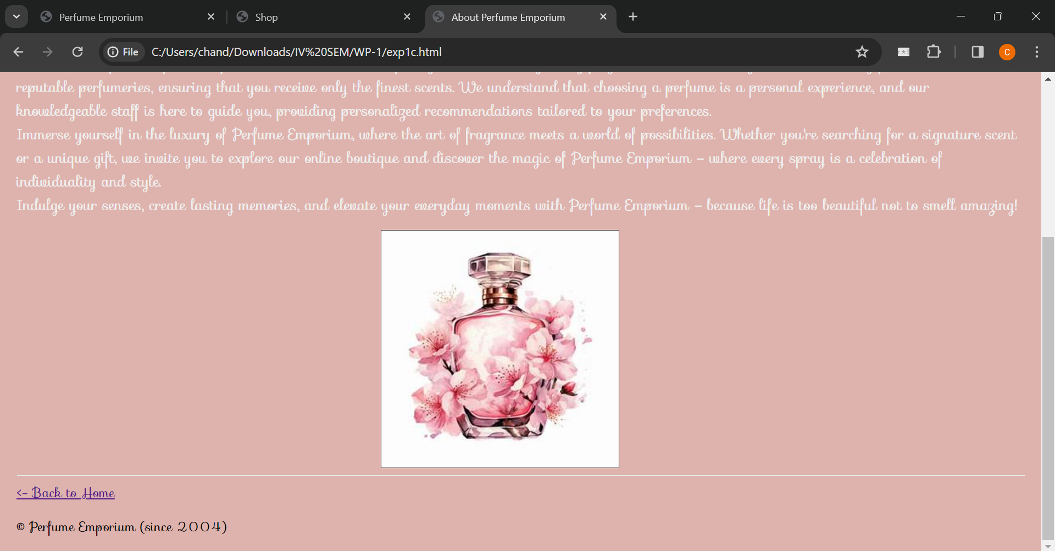

Clicking on ‘Back to Home’ in file 3, then on ‘Contact’ (present in the header section of file1)

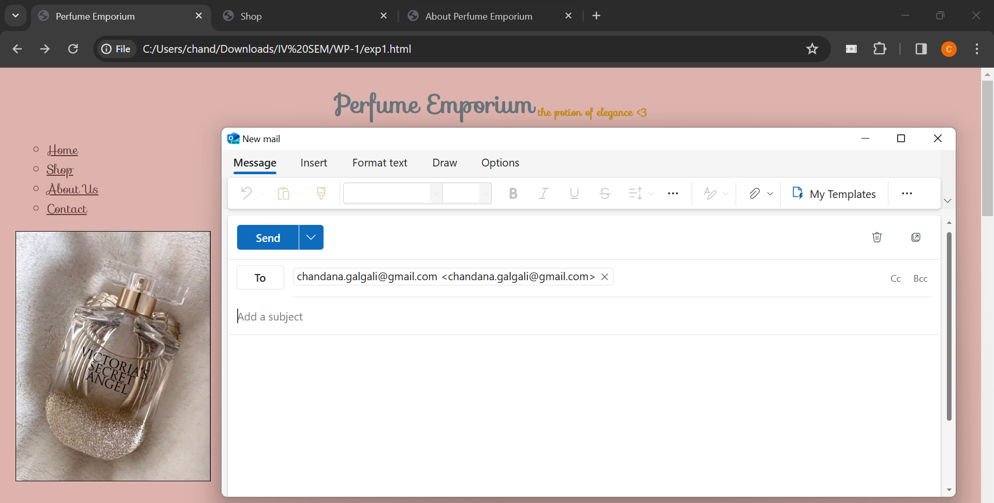

**Questions:**

**1. What is the difference between HTML and HTML5 tags?**

**Ans:** HTML5 is the latest version of HTML, and it introduces several new elements and attributes compared to its predecessor. Some key differences include:

New Semantic Elements: HTML5 introduces semantic elements such as <header>, <nav>, <article>, <section>, <footer>, etc., which help in better structuring the content of a web page.

New Form Elements: HTML5 introduces new form input types like <input type="date">, <input type="email">, <input type="url">, etc., making it easier to collect specific types of user input.

Audio and Video Support: HTML5 has built-in support for embedding audio and video content using <audio> and <video> tags, eliminating the need for third-party plugins like Flash.

Canvas and SVG: HTML5 includes the <canvas> element for drawing graphics using JavaScript and the <svg> element for scalable vector graphics.

Local Storage: HTML5 introduces the localStorage and sessionStorage objects for client-side storage of data, reducing the reliance on cookies.

Geolocation API: HTML5 provides a Geolocation API that allows websites to access the user's geographical location.

**2. Write the HTML code to nest tables within a table?**

**Ans:**

<html>

<head>

<title>Nested Tables Example</title>

</head>

<body>

<table border="1">

<tr>

<td>

<!-- Outer Table Content -->

<table border="1">

<tr>

<td>Inner Table Cell 1</td>

<td>Inner Table Cell 2</td>

</tr>

<tr>

<td>Inner Table Cell 3</td>

<td>Inner Table Cell 4</td>

</tr>

</table>

</td>

<td>Outer Table Cell 2</td>

</tr>

<tr>

<td>Outer Table Cell 3</td>

<td>Outer Table Cell 4</td>

</tr>

</table>

</body>

</html>

**3. What are the different ways to organize web page contents?**

**Ans:** HTML Structure: Organize your content using semantic HTML elements like <header>, <nav>, <main>, <section>, <article>, and <footer> for better readability and structure.

CSS Layouts: Use CSS for layout organization. Techniques like Flexbox and Grid provide powerful tools for creating responsive and well-organized designs.

Responsive Design: Implement responsive design principles to ensure your content adapts to different screen sizes and devices, enhancing user experience.

JavaScript Interactivity: Use JavaScript to add interactivity to your page. This includes dynamic content loading, form validation, and other user-engaging features.

Frameworks and Libraries: Leverage front-end frameworks like Bootstrap, Foundation, or JavaScript libraries like React or Vue.js to streamline the organization of your web page.

Content Management Systems (CMS): Consider using a CMS like WordPress, Drupal, or Joomla for efficient content organization and management, especially for larger websites.

SEO Best Practices: Implement Search Engine Optimization (SEO) best practices to organize and present your content in a way that is easily discoverable by search engines.

**_______________________________________________________________________________**

**Outcomes: Create Web pages using HTML 5 and CSS**

**_______________________________________________________________________________**

**Conclusion: (Conclusion to be based on objectives and outcomes achieved)**

The experiment demonstrated the effectiveness of using HTML5 tags in planning and designing a home page, laying a solid foundation for further development and refinement in the broader context

of web development.

_______________________________________________________________________________

**Grade: AA/AB/BB/BC/CC/CD/DD/FF**

**Signature of faculty in-charge with date**

**_______________________________________________________________________________**

**References:**

**Books/ Journals/ Websites:**

∙ “Web Technologies: Black Book”, Dreamtech publication

∙ <http://www.w3schools.com/>

___________________________________________________________________________